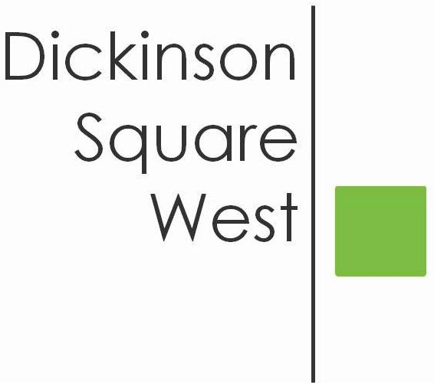
COMMUNITY BOARD MEETING
Tuesday, September 19, 2017 @ 7:30 PM
Mt. Moriah (410 Wharton Street)
MINUTES

- 7:30 Call to Order
- 7:30 President’s Welcome
- 7:35 Roll Call: PRESENT - Ted Savage, President, Josephine O. Rivera, Secretary, Chris Brick, Treasurer, Karen Rose, Heather Davis, Jeff Boettcher. ABSENT: Heather Shultz and George Kull
- 7:40 Approve Minutes: Jeff and Heather
- 7:45 Committee Reports:
- Directors - No Report
- Treasurer -Insurance Policy paid $875.00
- Zoning Committee - No Report
- Election Committee - DSWCA is required to post Election in public newspaper. Cost of advertisement approximately $300.00. Motion to approve by Josephine and Chris.
6. 7:50 Old Business:
- Fundraising/Dispatch/Website - Corporate sponsorship on behalf of PECO did not materialize. Fundraising Committee will meet after monthly meeting to discuss new avenues of fundraising.
- V2 Properties sponsoring clean-up on Saturday, September 23rd at 8:45 am on the 400 block Mercy Street. Volunteers are needed.
7. 8:00 New Business:
- Rebuilding Sacks Playground - Unfortunately our speaker, Eileen Talanian was unavailable to attend. The Philadelphia Water Dept. has approval to install tree trenches at the playground. This is part of a program called Green City. Clean Water. These trenches will be installed on the 500 block of Washington Avenue and on the 500 block of Federal. In addition to this upgrade, it is my understanding that a new children’s playground will be installed, together with new basketball courts and possibly a dog run. More info to follow.
- Elections for Board members and Directors will be held Tuesday, October 17, 2017.
8. 8:10 Guest Speaker: Sarah Radcliffe Miller, South Philly Food Co-op - Store is located at
2031 S. Juniper St. To join, please visit southphillyfoodcoop.org/join

9. 8:30 Adjournment

