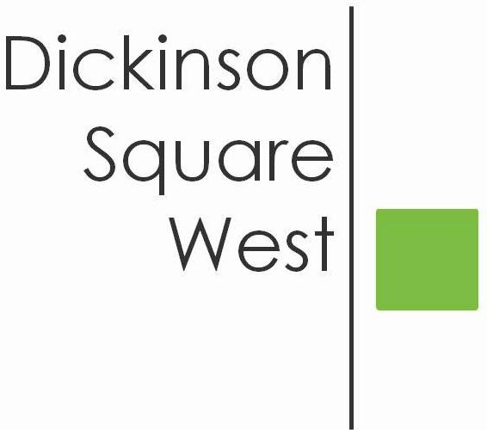
COMMUNITY BOARD MEETING
Tuesday, May 8, 2018 @ 6:30 PM
Mt. Moriah (410 Wharton Street)
MINUTES

- 6:30 Call to Order
- 6:30 President Jeff Boettcher welcomed all
- 6:35 Roll Call: Jeff Boettcher, Heather Davis, Josephine O. Rivera, Christopher Brick, Ted Savage, Courtney Bieberfeld, Jacki Mowery, Absent: Jamie McCrone
- 6:35 Approval of Minutes April 10th Meeting - Ted motioned to pass and Heather seconded. Minutes approved unanimously.
- 6:35 Jeff appointed 2 new Directors to the Board. Welcome Lily Godspeed and Matt Scheller. Jeff announced his resignation in order to fulfill his responsibilities as the Phillies Chaplain. Heather who is V.P. will step in as Acting President and will call a special meeting of the Board to discuss reorganization.
- 6:40 Committee Reports
- Beautification Committee Report:
- TreePhilly Yard Tree Giveaway was held Friday, April 20th at Vare-Washington School Yard. TreePhilly is the city agency who sponsored the program. DSWCA distributed 50 trees (various species) to Philadelphia residents to plant in their backyards and our Civic received a $300 grant for participating in the program. TreePhilly’s goal is to increase the tree canopy in the city.
- Illegal Signs Round Up - Clean PHL will donate $0.50 per sign, up to $250.00 for illegal signs that have been taken down. Bring illegal signs to our June 12th community meeting.
b. Fundraising Committee - No report update in June
c. Zoning Committee - 2 homes on the 500 block of Sigel are seeking a variance
for a proposed deck. Zoning Meetings are held the 4th Tuesday of every
month (if needed) at the Parson’s Bldg. at Dickinson Square Park @ 7 pm.
7. 6:45 Guest Speaker Councilman Mark Squilla updated our residents on various
topics:
Budget Season, Schools, 2019 Real Estate Tax increase proposal by the Office
of Property Assessment, AVI Legislation, Bureau of Revenue Taxes, (Programs
residents can apply for tax relief LOOP, Homestead, Owner Occupied Payment
Agreement “OOPA”) Zero Waste and Litter Cabinet programs, Street Cleaning,
Delinquent Investors to pay their share of taxes, 33.3 Million missing from the
City’s general fund, Bart Blatstein’s proposed development along Columbus
Avenue and Tasker - Reed Streets. Councilman Squilla can be reached by
email at mark.squilla@phila.gov.
8. 7:30 Adjournment

