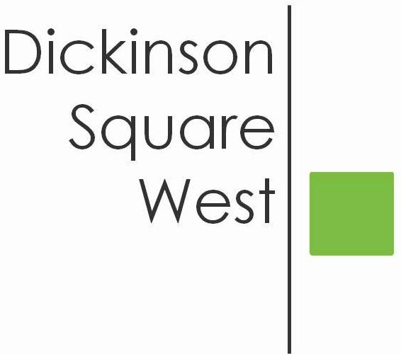
COMMUNITY BOARD MEETING
Tuesday, March 13, 2018 @ 6:30 PM
Mt. Moriah (410 Wharton Street)
MINUTES

- 6:30 Call to Order
- 6:30 President Jeff Boettcher welcomed all
- 6:35 Roll Call: Jeff Boettcher, Heather Davis, Josephine O. Rivera, Christopher Brick, Ted Savage, Courtney Bieberfeld, Jacki Mowery, Jamie McCrone
- 6:40 John Landers - PMBC Block Officer Presentation
- 7:15 Committee Reports
- Beautification Committee
2018 Philly Spring Meetup and Cleanup, Saturday, April 7, 2018 Board voted unanimously for two tables located at 5th & Moore and 5th & Federal as well as a budget not to exceed $500.00.
- Chris & Josephine will work the 5th Moore table
- Ted & Larry will work the 5th & Federal table
- Setup/Delivery of Table & Chairs - 5th & Moore - Courtney & Chris will delivery table and chairs. Jacki volunteered to provide 2nd folding table for the 5th & Moore location. 5th & Federal - Ted & Larry will delivery table and chairs.
- Deliver Supplies - To Be Determined
- Photos - Matt Scheller volunteered to take photos of the event
- Breakdown - Jacki, Jamie & Heather volunteered to handle the breakdown of tables & chairs and deliver to Josephine’s house for the Philly Yard Tree Event on Friday, April 20th
Philly Yard Tree Giveaway Friday, April 20th
- Set-up - Courtney, Josephine & Matt Borda
- Courtney & Jacki will greet registrants
- Heather & Josephine will verify registration
- Jamie & Matt Borda will hand out the trees and mulch
- 7:30 Adjournment

