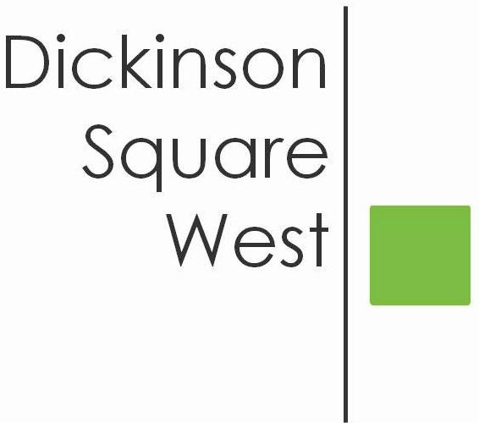
COMMUNITY BOARD MEETING
Tuesday, June 12, 2018 @ 6:30 PM
Mt. Moriah (410 Wharton Street)
MINUTES

- 6:30 Call to Order
- 6:30 President Heather Davis welcomed all
- 6:35 Roll Call: Heather Davis, Josephine O. Rivera, Jacki Mowery, Ted Savage, Courtney Bieberfeld, Jamie McCrone, Lily Goodspeed, Matt Scheller. Absent: Chris Brik
- 6:35 Approval of Minutes May 8th Meeting - Ted motioned, Jamie seconded. Minutes approved unanimously.
- 6:35 Heather opened the meeting with Jeff’s resignation and the reorganization of the Board. Heather Davis has been appointed President, Jacki Mowery has been appointed Vice President. 2 new Directors have been appointed Lily Goodspeed and Matt Scheller.
- 6:40 Committee Reports:
- Beautification: Courtney reported up to 58 signs collected to date. The program ends Saturday, June 16. If anyone finds a sign and rips it down, please contact info@dswca.org and Courtney will personally come to your home to collect. (Illegal Signs Round Up - Clean PHL will donate $0.50 per sign, up to $250.00 for illegal signs that have been taken down.)
b. Fundraising: Jamie reported that the newly designed DSWCA website will most
likely launch in the next 4-6 weeks. Jacki put together a proposed plan for
business advertisements on our web page which includes size, costs, length of ad, etc.
c. Zoning: 515 Sigel Street is seeking a variance for a proposed deck. Zoning Meetings
are held the 4th Tuesday of every month (if needed) at the Parson’s Bldg. at
Dickinson Square Park @ 7 pm. Meeting space at Park offered to Beautification
Committee to conduct meetings when no zoning meetings are scheduled.
d. Finance: Chris reported thru email - $300.00 was received from TreePhilly Yard
Tree Giveaway and DSWCA’s RCO application is due by June 30 which he will
complete and submit. Josephine requested financial statement and budget
projections for July’s meeting.
e. Social Media: The Dispatch (weekly e-newsletter) submission deadline every
Tuesday evening. Facebook, Twitter and Instagram will be administered by Matt
with assistance from Lily. DSWCA web page to be administered by Jamie.
DSWCA’s Promotion schedule for events - Depending on the event, 30 days out,
Save-the Date posts, etc. Social Media Protocol Guidelines were distributed to the
Board. Religious and political concerns regarding posts and events were raised. To
be determined case by case.
7. 6:55 Administrative Items: Amend ByLaws to include expansion of boundaries as well as
correct omissions and grammatical errors. Membership meeting October, 2018 will
include a vote from our membership regarding expansion of boundaries, amendments
to ByLaws, remove newspaper ad announcing Board Elections and advertise via our
social media platform, etc. Upcoming Clean Up dates 7/14 @ 5th McClellan,
Sept./Nov. @ 5th Pierce. Farmer’s Market - Heather will contact vendor in charge to
discuss DSWCA’s interest in hosting a table.
8. 7:15 Guest Speaker: Captain Frank Milillo addressed the community and distributed
contact information and PSA2 meeting dates at EOM.
9. 7:40 Adjournment

