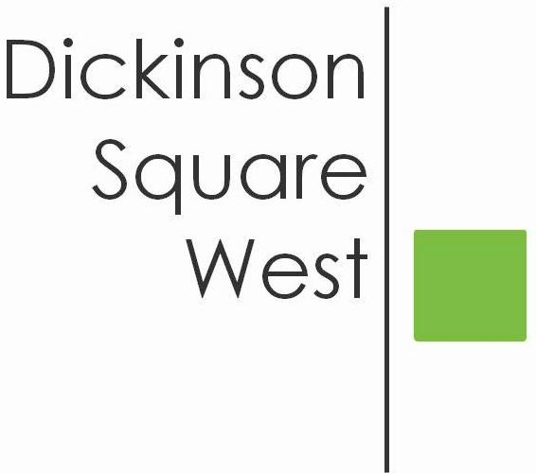
COMMUNITY BOARD MEETING
Tuesday, July 10, 2018 @ 6:30 PM
Mt. Moriah (410 Wharton Street)
MINUTES

- 6:30 Call to Order
- 6:30 Acting President’s Welcome - Jacki Mowery
- Greet Neighbors
- Ask all in attendance to to sign up for email at the welcome table if they are not currently on our mailing list
- Introduce Officers and Directors
- 6:35 Roll Call: Josephine O. Rivera, Chris Brick, Ted Savage, Courtney Bieberfeld, Jamie McCrone, Lily Goodspeed. Absent: Heather Davis, Matt Scheller
- 6:35 Approval of Minutes June 12th Meeting - Ted motioned, Lily seconded. Minutes approved unanimously.
- 6:35 Jacki opened the meeting with Heather’s temporary leave of absence thru 9/30/18 and the reorganization of O&D: Heather Davis, President (Maternity Leave); Jacki Mowry, V.P. now serving as Acting President; Josephine Rivera, Secretary (Agenda, Minutes, Speakers); Chris Brick, Treasurer (Finance Committee); Courtney Bieberfeld, Director (Beautification Committee); Ted Savage, Director (Dispatch); Jamie McCrone, Director (Website); Matt Scheller, Director (Social Media) and Lily Goodspeed, Director (Social Media)
- 6:45 Committee Reports:
- Beautification: Clean up scheduled for Saturday, July 14th @ 9:00 am located at 5th & Moore and 5th & Dickinson. Ted, Jamie, Josephine and Courtney volunteered to assist. $60.50 was raised by Courtney thru the program sponsored by Clean PHL called “ Illegal Signs Round Up”. PA State Representative Sims office has donated $250.00 in grant funds towards Safety Vests. Courtney proposed a contest wherein members send in their design for the vests.
- Fundraising: To be discussed offline.
c. Zoning: To meet and discuss to determine if we should coordinate any new
developments
d. Finance: RCO application filed on time.
e. Social Media: DSWCA’s Promotion schedule for events - Depending on the event,
30 days out, Save-the Date posts, etc.
7. 7:00 Administrative Items: Website - $179.00 approved to maintain newly designed
platform. Amend ByLaws. Membership meeting October, 2018 will
include a vote from our membership. Advertise in local newspaper as well as our
social media platform, etc.
8. 7:30 Adjournment

