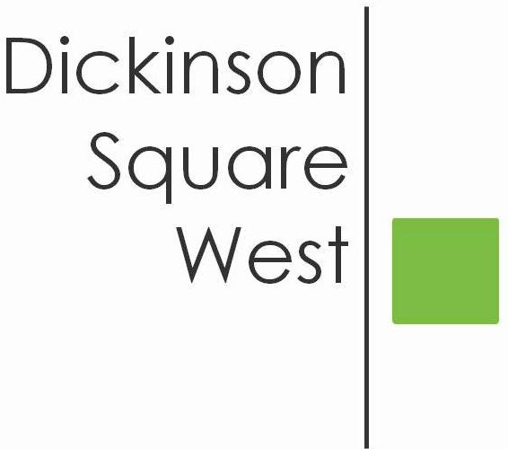
COMMUNITY BOARD MEETING
Tuesday, April 10, 2018 @ 6:30 PM
Mt. Moriah (410 Wharton Street)
MINUTES

- 6:30 Call to Order
- 6:30 Vice President Heather Davis welcomed all
- 6:35 Roll Call: Heather Davis, Josephine O. Rivera, Ted Savage, Courtney Bieberfeld, Jacki Mowery, Jamie McCrone Absent: Jeff Boettcher and Chris Brick
- 6:35 Committee Reports
Beautification Committee
- 2018 Philly Spring Meetup and Cleanup, Saturday, 4/14/18
9:00 am - 2:pm 5th & Moore and 5th & Federal
Courtney reported approximately $100.00 spent on
supplies and requested a volunteer to take photos.
Also requested remainder of sponsored funds be allocated
towards the purchase of 40 safety vests in the amount of
$382.00. Both Heather and Ted asked for the vote to be
placed on hold until the Finance Committee can provide an
update.
- Philly Yard Tree Giveaway Friday, April 20th - Need volunteer to take photos
Fundraising Committee - Plan to meet. Members can make a
donation towards the Civic thru Amazon Smile
Finance Committee - No Report
Zoning Committee - No Report
5. 6:40 Director’s Vacancy
Matt Scheller, Nominee - Resident of 2 years. Currently, volunteers for a multi-million dollar corporation. Well versed on event planning. Organized DSWCA’s Christmas Photo Contest.
Lily Goodspeed, Nominee - Resident of 5 years. Volunteered on various neighborhood committees (Bok, QVCA Summer Camp, EPX Zoning). Notary Public.
6. 6:45 Approval of Minutes of March Community Board Meeting
7. 6:45 Raincheck Workshop presented by Zach & Rosemary of PHS
8. 8:00 Adjournment

