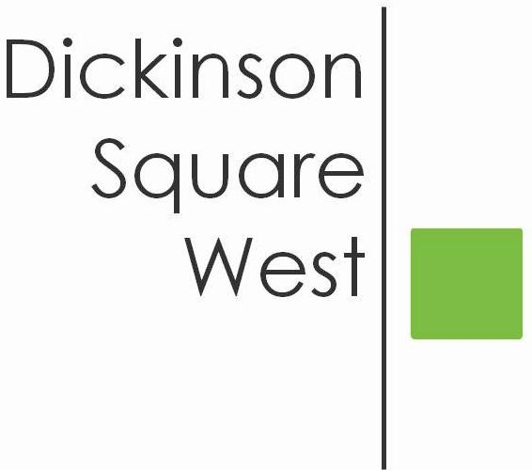
COMMUNITY BOARD MEETING
Tuesday, February 13, 2018 @ 6:30 PM
Mt. Moriah (410 Wharton Street)
Minutes

- Call to Order
Jeff called the meeting to order at 6:30 p.m.
- President’s Welcome
- Roll Call of Officers/Directors
Present: Jeff Boettcher, Heather Davis, Chris Brick, Courtney Bieberfeld, James McCrone, Jacleen Mowery
Farrell, Samantha Mayo
Absent: Josephine Rivera, Ted Savage
- Approve Minutes

- Committee reports
  - Beautification
    - Free Yard Tree Giveaway: Applied for 50 trees to giveaway in April; will be notified by 2/16/18. Courtney will reach out to Zack Duberstein at Vare Washington as a potential host location.
    - 11th Annual Spring Cleanup is Saturday 4/7/18. The Board discussed creating an advertising campaign for the event to include the Dispatch, social media, flyers for mailboxes and local businesses. Board agreed to use 5th and Moore and 5th and Reed as meet up spots for attendees. Board is going to seek sponsorship for the event for refreshments, as well as, supplies that can be used for the beautification committee.
    - Next month’s speaker: Clean Block Officer John Landers
  - Fundraising
    - Update on PayPal account: Chris is in process of setting up the PayPal account. Jacki will connect with Chris to set up a donate button on Facebook page.
    - Update from committee about fundraising options: Heather presented the Board with pricing options for potential advertisements with the Civic. The Board discussed the price points as concern was expressed that the pricing was too high. The Board agreed to use this as a baseline test and will re-evaluate after implementation. Jacki and Heather are going to design a pamphlet that can be used to solicit local business. Jeff said that before approaching any business we must make sure that we have the logistical details worked out for how we will manage running these advertisements.
Jamie moved, and Chris seconded, to approve the pricing with dimensions for Facebook and Mailchimp advertisements forthcoming. The motion passed unanimously.
  - Zoning: There were no Zoning updates at this time.
- Administrative business
  - Social media policy update: Jacki distributed to the Board statistics for the month of January in regards to Facebook followings. Jacki also distributed several potential categories to pull into a social media policy. The Board provided Jacki with feedback and will continue to do so as this policy is formed.
  - Events checklist: The Board discussed and agreed to use the Spring Clean Up as an a template to create an event checklist.
  - Google Drive: This item will be pushed to the March meeting agenda when Ted and Josephine are present and can provide an update.
  - Town Watch Update: Courtney inquired with the Police Captain who advised against patrolling the neighborhood. The Police Captain advised instead of having a “eyes and ears” program. Courtney will connect with individuals who expressed interest in Town Watch about this possibility.
  - Grants Applications: Courtney received a list of grants from Rep. Brian Sims’ office. Heather offered assistance in going through the list of grants to determine what is applicable to the Civic.
- Old business
  - Expanding Civic Boundaries to include Mifflin to Snyder Avenue, 4th to 6th: The Board discussed the interest in expanding the Civic Boundaries. As there has been no further movement on this item, the Board agreed to table the conversation until further interest is expressed.
- New Business
  - DSWCA/Friends of Vare-Washington Chili Cook-off: Chris investigated into liability insurance in regards to events through the current insurance provider. One-day event coverage will cost approximately $600.
The Board had a general discussion regarding the interest in the event. The Board was in agreement to move forward with the event and would cover the cost of the insurance. Before moving forward though, a venue needs to be determined.

9. Upcoming business
Jeff confirmed that Rep. Squilla is scheduled to speak to the community. Jeff will confirm the date with Josephine and inform the rest of the Board.

The Board agreed to conduct outreach to the festivals in the area and farmers markets in order to promote the Civic further to the community.

